## Impact of Air Pollution on our Lives

**Objective**

The main object is that Impact of Air Pollution on our lives by considering the key factors as Vehicles and Industries. Here we have access to a large amount of granular data relating to the concentration of major air pollutants in India and it will be interesting to see if the claim of reduced air pollution is being actually backed by data. Before going further let's understand about the constituents of Air Pollution

**Types of Air Pollutants**

Let's first try and understand the various types of air pollutants in the datasets. On a broader level, these pollutants can be classified as :

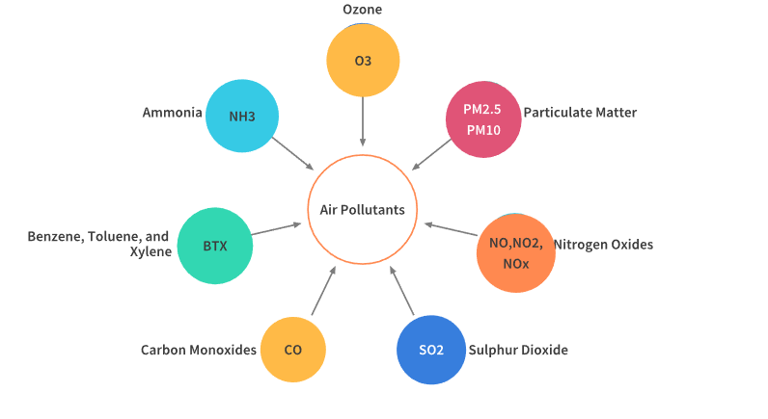

* **Particulate matter (PM2.5 and PM10)**

Particulate matter is a mix of solids and liquids, including carbon, complex organic chemicals, sulphates, nitrates, mineral dust, and water suspended in the air. PM varies in size. Some particles, such as dust, soot, dirt or smoke are large or dark enough to be seen with the naked eye. But the most damaging particles are the smaller particles, known as PM10 and PM2.5.

* **Nitrogen Oxides** (NO, NO2, NOx)

Nitrogen oxides are a group of seven gases and compounds composed of nitrogen and oxygen, sometimes collectively known as NOx gases.The two most common and hazardous oxides of nitrogen are nitric oxide(NO) and nitrogen dioxide(NO2)

* **Sulphur Dioxide**(SO2)

Sulphur dioxide, or SO2 is a colorless gas with a strong odor, similar to a just-struck match. It is formed when fuel containing sulfur, such as coal and oil, is burned, creating air pollution.

* **Carbon Monoxide**(CO)

Carbon monoxide is a colorless, highly poisonous gas. Under pressure, it becomes a liquid. It is produced by burning gasoline, natural gas, charcoal, wood, and other fuels.

* **Benzene, Toluene and Xylene** (BTX)

Benzene, toluene, xylene, and formaldehyde are well-known indoor air pollutants, especially after house decoration. They are also common pollutants in the working places of the plastic industry, chemical industry, and leather industry

* **Ammonia**( NH3)

[Ammonia pollution](https://en.wikipedia.org/wiki/Ammonia_pollution) is pollution by the chemical ammonia (NH3) – a compound of nitrogen and hydrogen which is a by product of agriculture and industry.

* **Ozone**(O3)

[Ground-level ozone](https://www.canada.ca/en/environment-climate-change/services/air-pollution/pollutants/common-contaminants/ground-level-ozone.html) is a colorless and highly irritating gas that forms just above the earth's surface. It is called a "secondary" pollutant because it is produced when two primary pollutants react in sunlight and stagnant air. These two primary pollutants are nitrogen oxides (NOx) and volatile organic compounds (VOCs).

## Methodology

The analysis has been done in two parts:

* Analysis of the pollution level in India, over the years - from 2015 to 2020
* Effect of Lockdown on the Pollution level in India

Analyzing data under these different categories gives us a fair idea of the effect of Lockdown on the Indian pollution level.

**Visualising yearly data:**

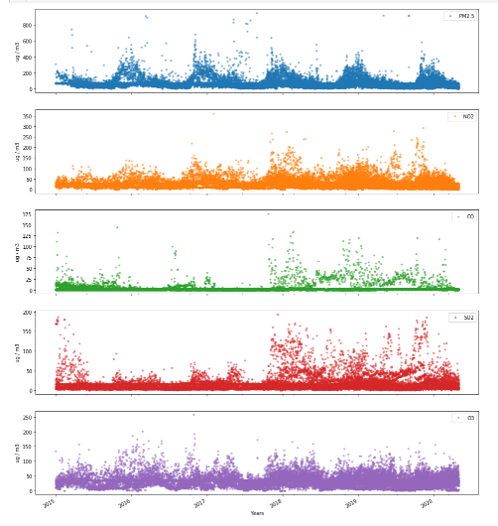

* PM2.5 has pollution show a seasonal effect, with pollution being higher in winter months as compared to the summer ones.
* SO2 level has started increasing after 2017, although it had also seen a sudden rise in 2015 also. Even NO2 has also started increasing

## Year and Month wise distribution

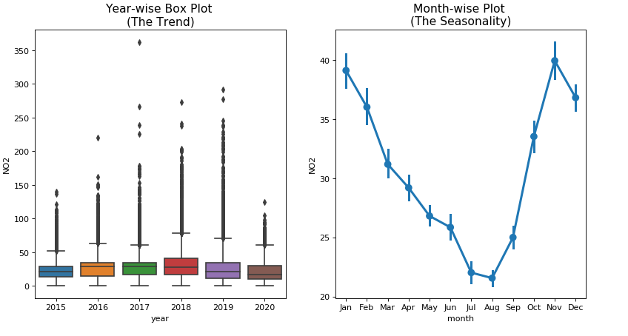

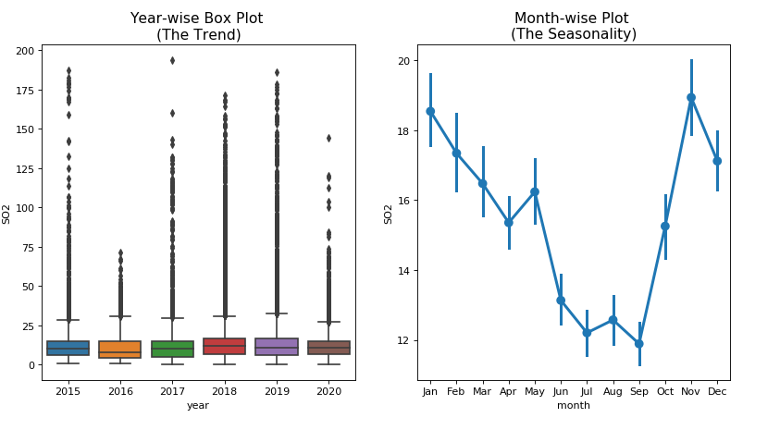

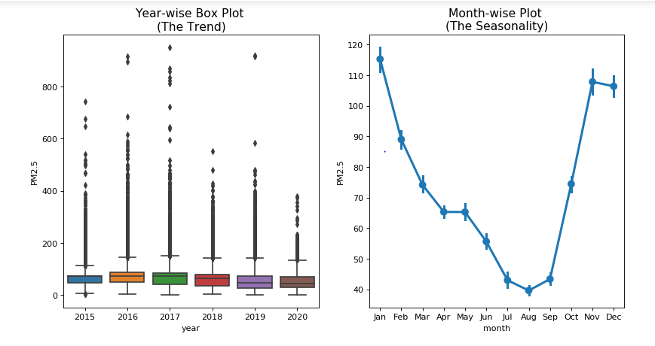

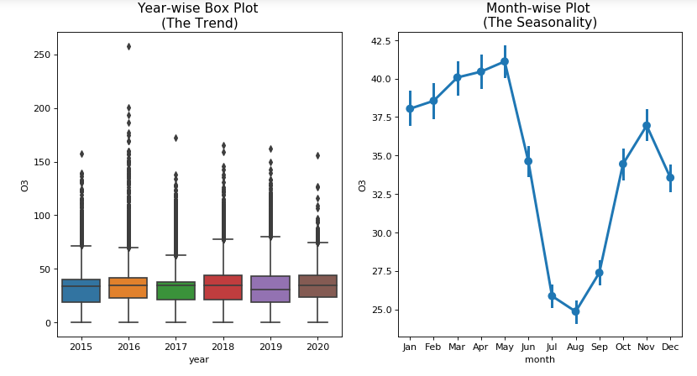

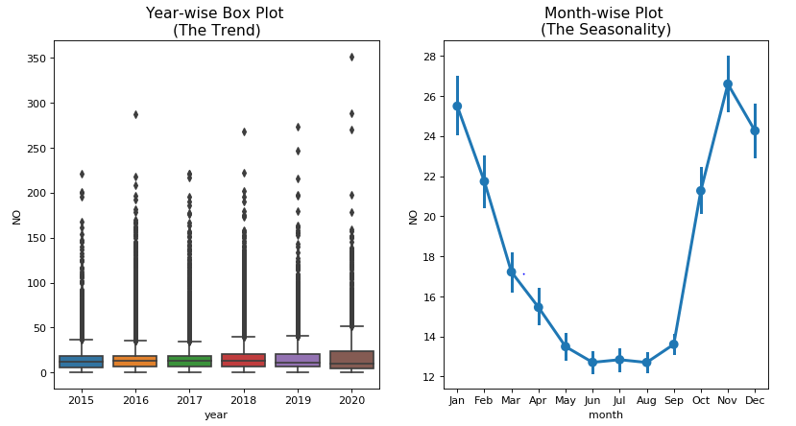

* There is a clear trend that pollution level in India falls in the month of July and August. This might be majorly because monsoon season sets in during these months.
* The pollution level then start rising and reach highest levels in winter months. Again, its during these months that a lot of crop residue burning takes place, especially in northern parts of India.
* SO2 level has started increasing after 2017, although it had also seen a sudden rise in 2015 also.
* The median values of 2020 are generally less as compared to other years giving us a sense that there might be a reduction on pollution lately.

# Most Polluted Indian Cities

Let's now look at the Indian cities which contribute to maximum pollution. We shall output the top 10 cities in each pollutant category by mean concentration of the pollutant over the years.Government of India has laid down [National Ambient Air Quality standards (NAAQS)](http://www.indiaenvironmentportal.org.in/files/file/Permissible%20Level%20for%20Pollutants.pdf) for twelve air pollutants, namely, PM10, PM2.5, Carbon Monoxide (CO), Sulphur Dioxide (SO2), Nitrogen Dioxide (NO2), Ammonia (NH3), ground level Ozone (O3), Lead, Arsenic, Nickel, Benzene and Benzo (a) Pyrene. The relevant standards are mentioned below:

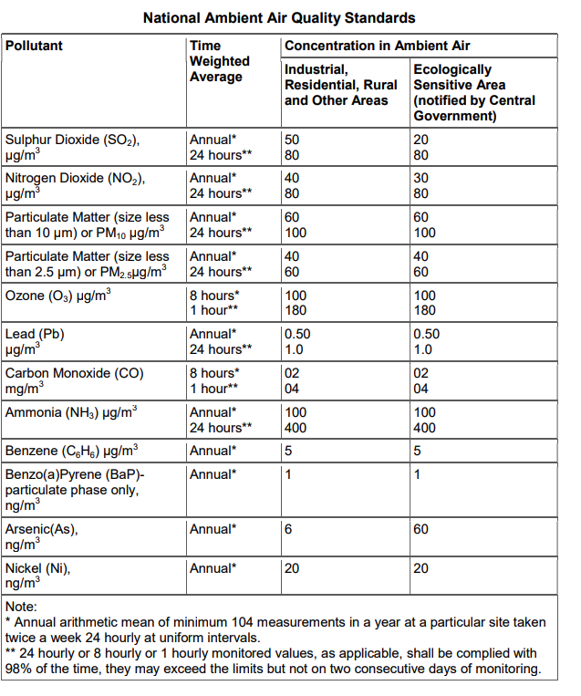

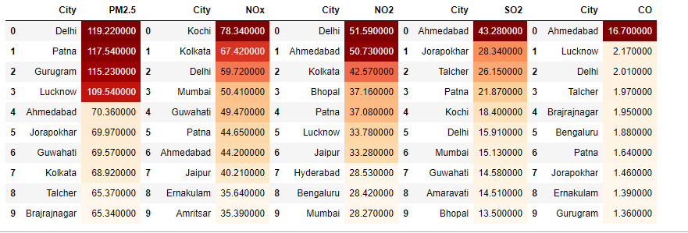

Delhi , Ahmedabad and Kochi seem to top the charts. Ahmedabad has maximum concenterations of NO2,SO2 as well as CO levels even Delhi has maximum concentrations of PM2.5,NO2

# Effect of Lockdown on AQI

Let's now see how has the Lockdown affected the AQI levels in the prominent cities of India.For this we shall consider the data from 2019 onwards only. But before that let's understand what AQI is:

## AQI : Air Quality Index

An air quality index (AQI) is used by government agencies to communicate to the public how polluted the air currently is or how polluted it is forecast to become. There are six AQI categories, namely Good, Satisfactory, Moderately polluted, Poor, Very Poor, and Severe. The proposed AQI will consider eight pollutants (PM10, PM2.5, NO2, SO2, CO, O3, NH3, and Pb) for which short-term (up to 24-hourly averaging period) National Ambient Air Quality Standards are prescribed. Based on the measured ambient concentrations, corresponding standards and likely health impact, a sub-index is calculated for each of these pollutants. The worst sub-index reflects overall AQI. Likely health impacts for different AQI categories and pollutants have also been suggested, with primary inputs from the medical experts in the group. The AQI values and corresponding ambient concentrations (health breakpoints) as well as associated likely health impacts for the identified eight pollutants are as follows:

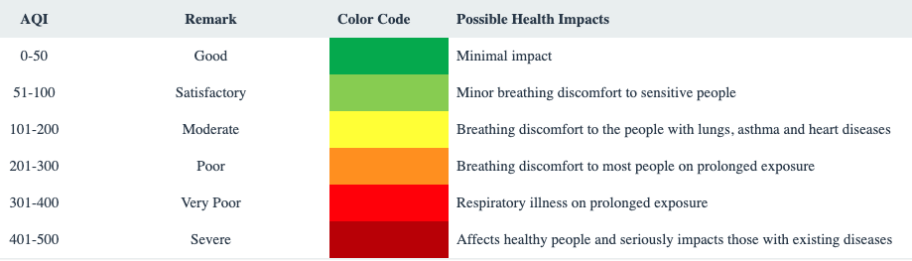

## AQI for some of the major cities of India

The cities that will be the subject of our study are - Ahmedabad, Delhi, Bengaluru, Mumbai,Hyderabad and Chennai.

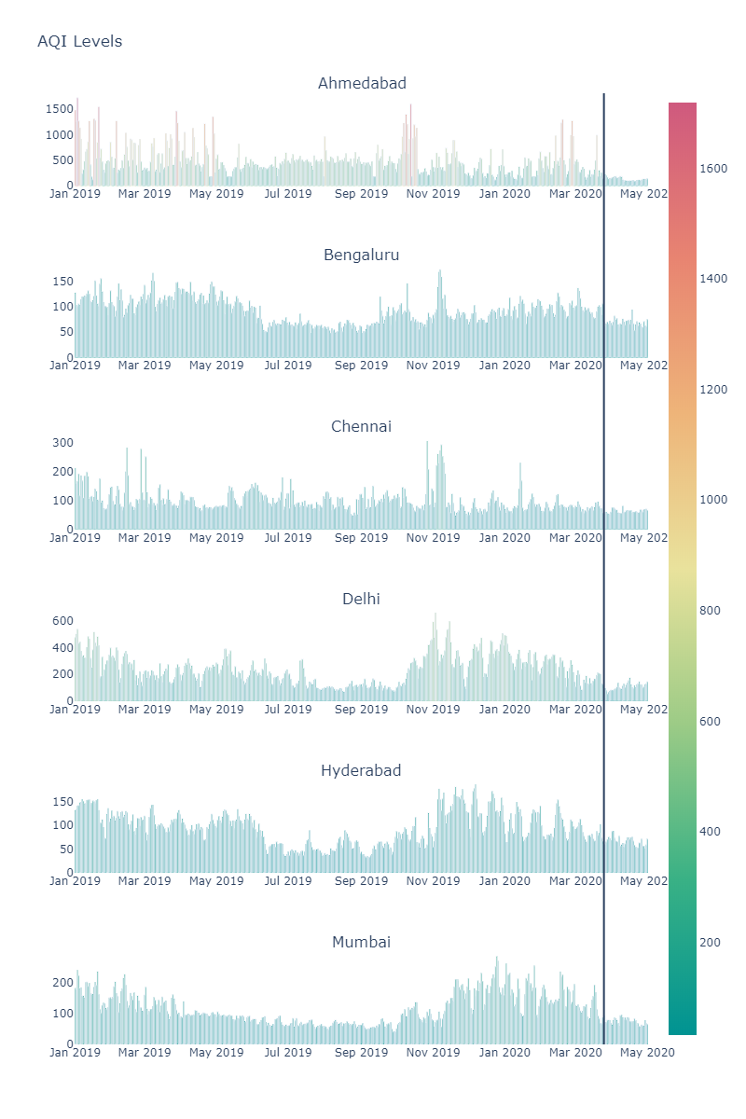

* The black vertical line shows the date on which the first phase of lockdown ame into effect in India.
* The above graph shows the variation of various pollutant levels, from Jan 2019 onwards till date.
* Apparantely, all the above Indian cities seem to be a dangerously high level of pollution levels.
* Clearly, there appears to be a rapid decline after 25th March,2020 in all the cities under sonsideration.

## AQI before and During Lockdown

## 

# Effect of Lockdown on levels of Individual pollutants

Let's compare the level of pollutants between 26-March-2019 to 01-May-2019 and 26-March-2020 to 01-May-2020 . This will give an idea whether the pollution levels have actually subsided or the pollution actually remains low during the onset of summer in India.

## A comparison between pollution levels in 26-March-2019 to 01-May 2019 VS 26-March-2020 to 01-May 2020

## C:\Users\hp\Downloads\newplot (13).pngC:\Users\hp\Downloads\newplot (14).png

## C:\Users\hp\Downloads\newplot (15).pngC:\Users\hp\Downloads\newplot (16).png

## C:\Users\hp\Downloads\newplot (17).pngC:\Users\hp\Downloads\newplot (18).png

## C:\Users\hp\Downloads\newplot (19).pngC:\Users\hp\Downloads\newplot (20).png

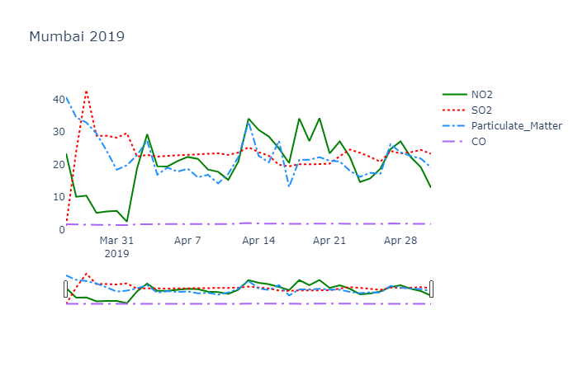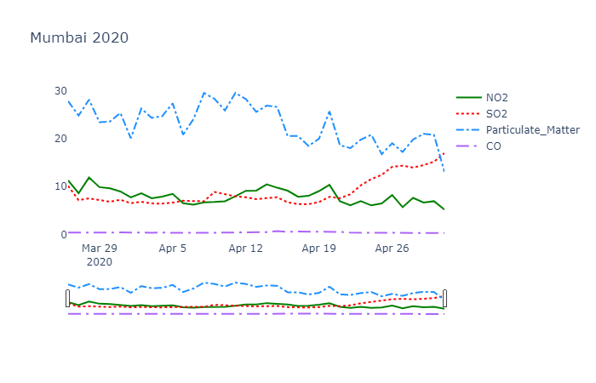

* It is interesting to note that the Pollution level in India genrally drops down as summer approaches. This can also be corroborated by the graphs above.
* However, the reduction in march 2020 is more pronounced as compared to march 2019